(Approx. 339 words)

Thinkware Dashcam Review
By George Harding, Treasurer, Tucson Computer Society
April 2017
www.aztcs.org
actuary110 (at) yahoo.com

This small device gives you a recording of your view out the front window of your r car. It attaches to the windshield with a sticky patch and connects with the power socket in your car with an included cable.

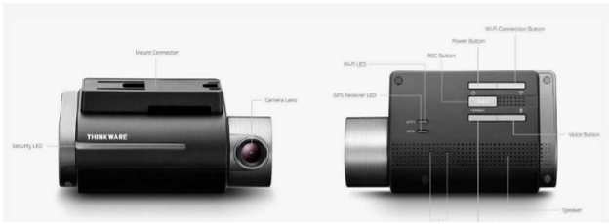

The list of features is impressive! In addition to recording in normal mode, additional modes are incident recording, parking surveillance and manual modes.

Normal recording mode keeps a record for pre-set interval lengths, from 1 minute to about 2 hours. Incident recording means that when an impact occurs, the period 10 seconds before and 10 after are automatically saved for evidentiary purposes. Manual recording lets you record when you want. Recording for all modes is 1080p and 30 fps.

Many of the controls for the dashcam are available through a downloadable app for your iOS or Android phone. This tool only works when it connected to the dashcam by Wi-Fi.

To connect to Wi-Fi, you must press the Wi-Fi button on the dashcam, look in Settings/Wi-Fi for Thinkware and connect to start the network. A password only needs to be entered once. Then go back to the app and connect to Wi-Fi. Normal and other modes of recording are suspended while in Wi-Fi mode.

A microSDHC card is included, which provides 16GB, 32GB or 64GB of recording space, depending on the model. There are several sections in the card in which data are stored.

GPS is built in and speed and location are stored as data is recorded.

Two additional features are LDWS (lane departure warning system) and FCWS (Front collision warning system) which give you safety warnings to help you drive safely.

The included Quick Start Guide (English and French) is a very helpful source of info for both setting up and operating the dashcam.

The Thinkware Dashcam is a compact, useful device to keep a record of your driving and provides data when an incident occurs.

Thinkware Dashcam www.thinkware.com Price $225 (Amazon)

